Wilson football prep kit
Price: Approximately Rs 10,999
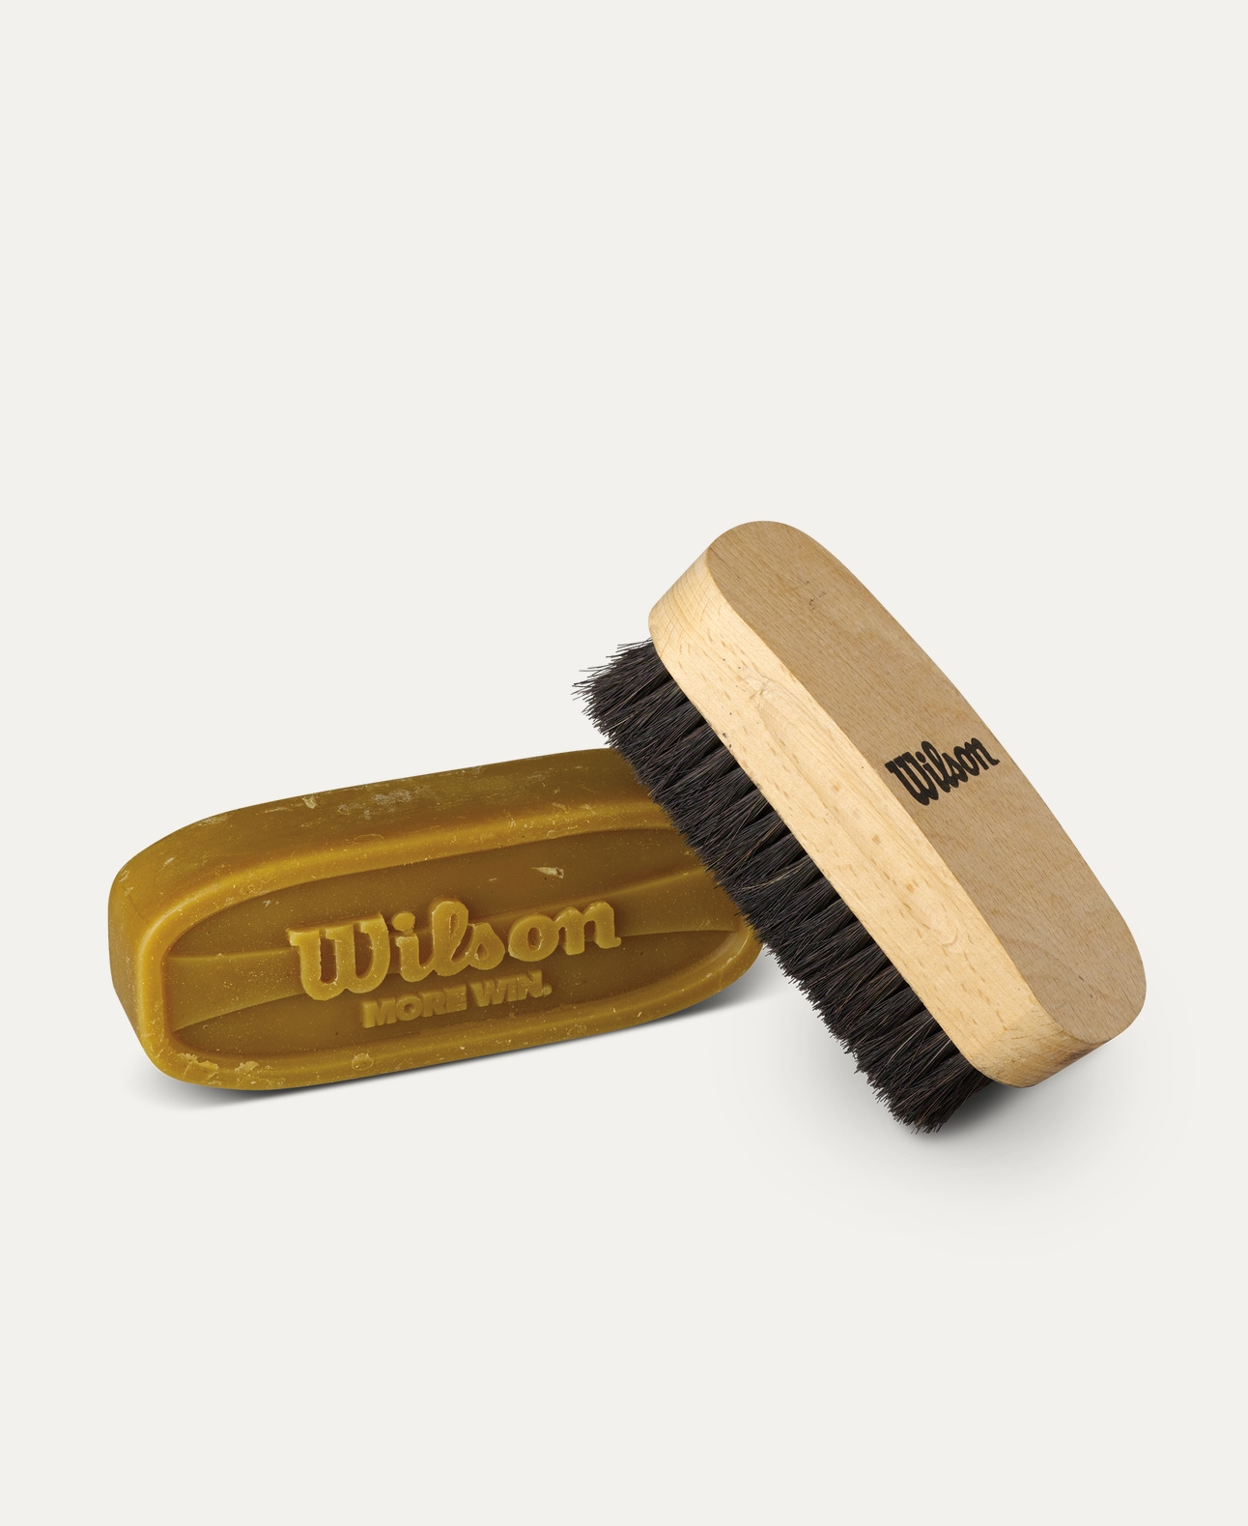
Introduction
The Wilson Football Prep Kit is designed to help maintain and enhance the performance of footballs. Ideal for teams, schools, and academies, this kit ensures footballs are game-ready with proper grip and finish.

Product Overview
This Wilson Football Prep Kit includes essential tools used to prepare footballs for practice and match play. It helps improve grip, remove excess coating, and condition the ball surface for better handling.

About the Brand
Wilson is a globally recognized sports brand and an official supplier for professional football leagues. Wilson prep kits are trusted by teams and officials to maintain footballs at professional playing standards.

Key Features
- Improves football grip and handling
- Helps condition the ball surface
- Easy-to-use preparation tools
- Suitable for training and match footballs
- Professional-grade accessories

Design & Build Quality
The kit components are designed for practical use with durable materials that withstand repeated preparation sessions. Each item is compact and easy to handle.

Storage & Capacity
The kit comes in a compact package that can be easily stored in equipment bags or lockers without taking much space.

Material & Durability
Made from high-quality materials designed for regular use, the Wilson Football Prep Kit offers long-lasting performance throughout the season.

Ideal For
- Football teams and clubs
- Coaches and equipment managers
- Schools and sports academies
- Training and competitive matches

Care Instructions
- Clean tools after each use
- Store in a dry place
- Keep away from moisture when not in use
- Use as per recommended guidelines

Product Specifications
- Brand: Wilson
- Product Type: Football Prep Kit
- Includes: Ball prep accessories (varies by model)
- Usage: Football preparation & maintenance

Product Summary
The Wilson Football Prep Kit is an essential accessory for maintaining football performance and grip. Trusted by professionals, it helps ensure footballs are properly prepared for optimal play.

Thank you

